1. Infra re Object Detection :

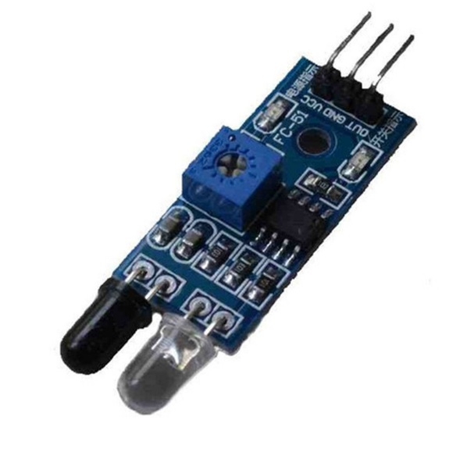

Infra Red Object detection only Range is 2:30 cm, Function to avoid colliding/Impact with other object and people

Specifications:

* Effective Range:    2:30 cm (Adjustable by potentiometer)
* Voltage Supply:      3.3: 5Vcc
* Detection Angle:     35°
* The comparator uses the LM393
* LED indicator (red---> power on, Green---> detection)
* Digital output

Pseudocode :

Sensor Pin X

Var to read Sensor XX

XX = reading of (X)

If (xx== High) Move to the other direction 5 cm

Example Pf three sensor Right , left and front Arduino Code :

int sensR= 8;

int sensF= 7;

int sensL= 9;

void setup ()

{

pinMode(sensL, INPUT);

pinMode(sensR, INPUT);

pinMode(sensF, INPUT);

}

sL= digitalRead(sensL);

sF= digitalRead(sensF);

sR= digitalRead(sensR);

void loop(){

sL= digitalRead(sensL);

sF= digitalRead(sensF);

sR= digitalRead(sensR);

if (sF== HIGH) {

backward(5);

}

if (sF== LOW) {

if (sL==HIGH && sR== LOW){

right(2.5);

}

if (sL== LOW && sR== HIGH){

left(2.5);

}

if (sL== HIGH && sR == HIGH){

left(2.5);

}

if (sL== LOW && sR== LOW){

forward();

}

}

1. Infra red Object detection and distance measuring

[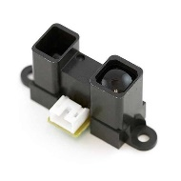](https://store.fut-electronics.com/products/sharp-ir-proximity-and-range-finder-sensor-15-150-cm) [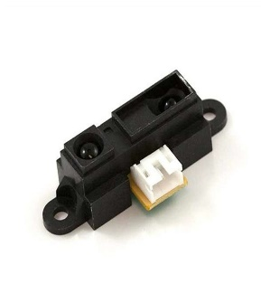](https://store.fut-electronics.com/products/sharp-ir-proximity-and-range-finder-sensor-10-80-cm)

Function to avoid colliding and keeping or measuring distance also

Arduino Code :

int sensorPin = 0;

void setup()

{ Serial.begin(9600); }

void loop()

{

int val = analogRead(sensorPin); Serial.println(val); // read the distance

delay(100);

}

* 1. varies from 2.8V at 15cm to 0.4V at 150cm.
  2. varies from 3.1V at 10cm to 0.4V at 80cm

1. Infra red Transmitter and receiver:

[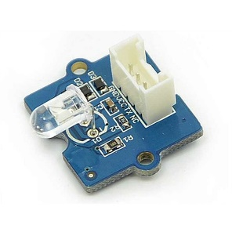](https://store.fut-electronics.com/products/infrared-emitter-module) [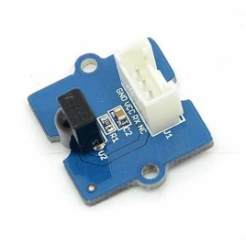](https://store.fut-electronics.com/products/infrared-receiver-module) 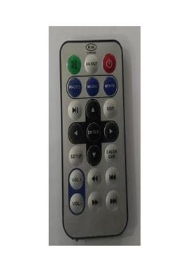 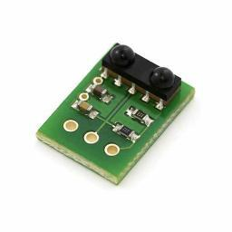 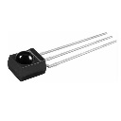

[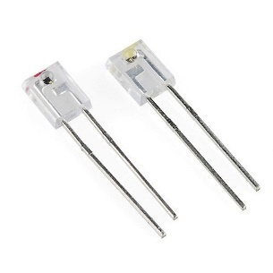](https://store.fut-electronics.com/products/infrared-transmitter-and-reciever-kit)

Function : Using remote control to connect and control the Robot within 10 meters range .

Code is via Library I already have the library with some examples

1. PIR Motion sensor module

[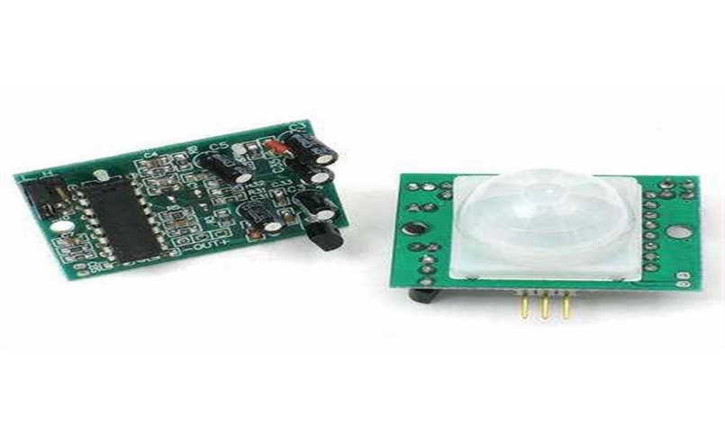](https://store.fut-electronics.com/products/pir-motion-sensor-module-adjustable-range) [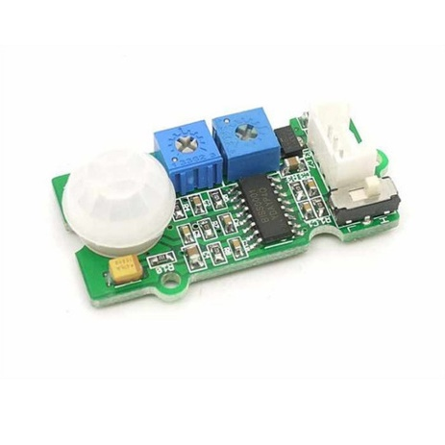](https://store.fut-electronics.com/products/pir-sensor-adjustable-range-and-detection-time)

Only detect humans or alive Motion within 7 m

Same Code of the First IR , but with reversed function